Installing Extensions

There are two ways to get to the extensions.

With the ICON

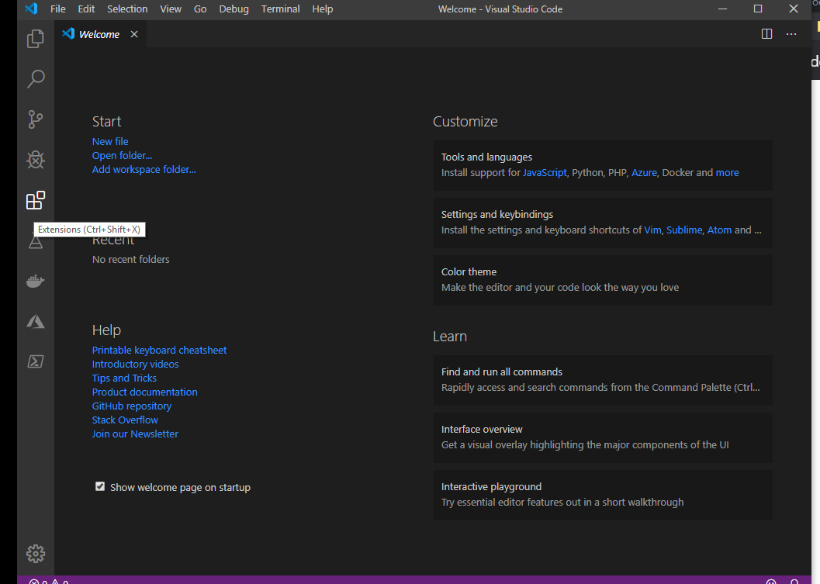

With menus or shortcut keys CTRL-SHIFT-X

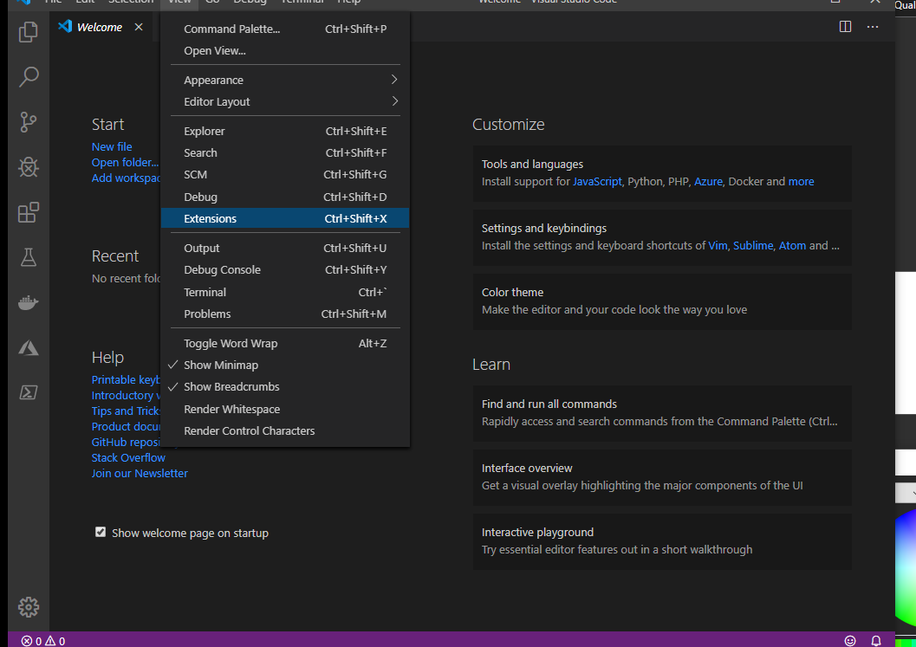

Once inside you search for your extension and click on install. That is all there is to it in most cases.

